Guidelines for public and corporate contractors
Washing machines  UPDATE: April 2021 | 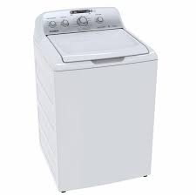

Why adopt the Topten criteria?

- Topten is an initiative based on active web portals in different parts of the world that helps professionals, public contractors and large buyers to find the most energy-efficient products available in each country. Products are continuously selected and updated according to their energy efficiency and environmental performance. This is independent of manufacturers.
- All washing machines shown on www.topten.pe meet the criteria contained in these guidelines. Therefore, buyers can use the website to check the availability and variety of products currently on the market that meet Topten's selection criteria.

How much can you save?
At www.topten.pe washing machines are divided into the following categories:

LAVADORAS

Taking into account the models listed in Topten and the following considerations, it is possible to achieve the savings indicated in the table below.

Considerations | - Lifetime: 15 years
 | - Water cost: 1.354(S/ / m3 )
 | - Electricity cost: 0.5 S/./kW.h

 | Topten model: Washing machine 8 kg - 14 kg | Inefficient Model Washing machine 8 kg - 14 kg
Energy class | A+++, A++, A+,A | B, C y D
Energy consumption | 190 kWh/year | 266 kWh/year
Water consumption | 49720 l/year | 59664 l/year
Electricity cost in 15 years | S/. 95 | S/. 133

Savings over 15 years | 38 S/. / unit | 40% energy

Note: A total of 250 cycles of use in a year were considered. This provides information on the energy consumption and water consumption in one year of a topten model and inefficient model washing machine, as well as the savings over 15 years.
Topten models consume 40% less energy, compared to inefficient models and can achieve savings of an average of 38 S/. /unit during its lifetime.
Purchasing criteria
In the lists on the website, we select the household washing machine models with the lowest consumption and highest energy efficiency, according to the manufacturer's technical data sheet and based on the selection criteria of the Peruvian technical regulation.
Topten's selection criteria are mentioned and can be inserted in the bidding documents:
SUBJECT: ENERGY-EFFICIENT WASHING MACHINES
TECHNICAL SPECIFICATIONS
- Energy class
Washing machines must have energy efficiency class of A+++, A++, A+, A.
Summary of energy and spin classes allowed in the Peruvian market.
- Energy efficiency classification
The energy efficiency rating for washing machines is determined according to the following tables:
EEI: The Energy Efficiency Index of a household washing machine is determined with the following arrangement. The higher this number, the more efficient the equipment is.
The following table shows the energy efficiency classes of household washing machines according to the IEE index:
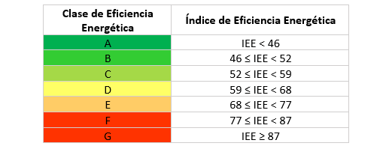
Spin efficiency class (D): indicates how dry the laundry is after being spun by the equipment in a normal cotton wash cycle. According to the water extraction efficiency (D). A corresponding spin efficiency class is assigned, ranging from the letter G (least efficient) to the letter A (most efficient):
The following table shows the Centrifuge Efficiency Classes
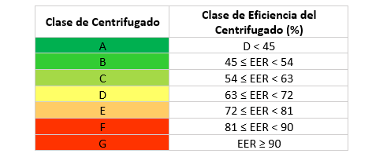
To increase savings and reduce environmental impact, it is recommended that buyers should evaluate life-cycle costs when bidding for washing machines.

Purchasing tips
Choose efficient class equipment: A+++/A.
Prefer equipment with Inverter technology. This type of technology reduces the friction of the parts, saves energy, and reduces the noise of the equipment.
Select the type of load according to your needs and preferences.
- Top loading: These machines are narrower, so they can be placed in small spaces. They allow interrupting a wash cycle to remove or add more clothes.
- Front loading: They can be placed under countertops.
Select the most efficient washing system that best suits your needs and preferences. There are three on the market:
- European system (front or top loading): They consist of a drum with a horizontal axis that rotates together with the garments, reversing the direction of rotation and pausing for the soap to act. It performs a gentler treatment of the fabrics.
- Eastern system (top-loading): In a vertical shaft drum, a turbine or central pulsator rotates in both directions and at high speed, agitating the water. Dirt is removed from the garments by friction.
- American system (top-loading): Consists of a vertical shaft drum with a central agitator with paddles, which moves back and forth. The clothes inside the drum are washed by friction. In general, they consume more water.
Choosing the right size is important, since a small unit for your amount of laundry will force you to do more washes and use more energy. At the same time, a very large machine (half full) wastes energy.
Choose a washing machine with a load capacity adapted to your needs: A very efficient appliance, but too large will waste energy, as it will be more difficult to use it at full load. We advise you to follow the recommendations below:
Number os users | Recommended capacity
1 – 2 | 5 -6,5 kg
3 – 4 | 7 – 8 kg
5 or more | 9 kg or more
There are units that have an ecological or energy saving program. Check the equipment characteristics to see if this function is included.
Advice and support
For further assistance in using the information presented, please contact the Topten national team (find links at www.topten.pe).

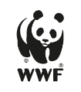 | The elaboration of these procurement guidelines has been supported by funding from WWF Switzerland. The sole responsibility for the content of the Topten procurement guidelines lies with the authors.

Topten ACT has received funding from the European Union's Horizon 2020 research and innovation programme under grant agreement nº649647. The sole responsibility for the content of the Topten Pro procurement guidelines lies with the authors. It does not necessarily reflect the opinion of the European Union. Neither EASME, nor European Commission and project partners are responsible for any use that may be made of the information contained therein.

