GUIDELINES FOR PUBLIC AND CORPORATE CONTRACTORS

REFRIGERATORS  UPDATE: April 2021 | 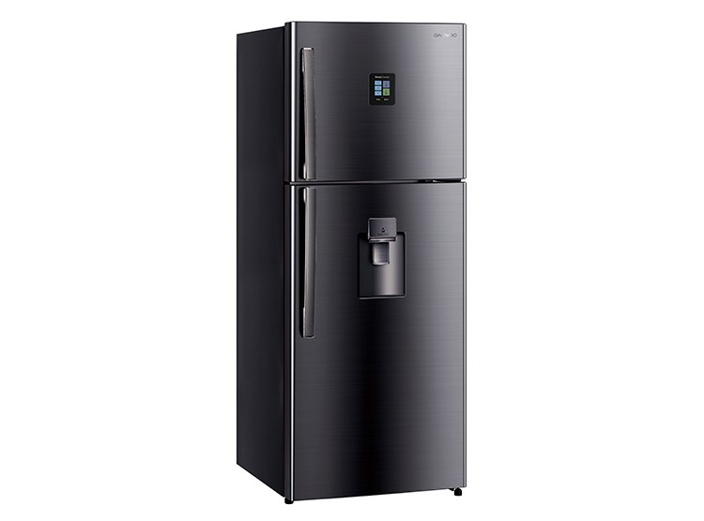

WHY ADOPT THE TOPTEN CRITERIA?

- Topten is an initiative based on active web portals in different parts of the world that helps professionals, public contractors and large buyers to find the most energy-efficient products available in each country. Products are continuously selected and updated according to their energy efficiency and environmental performance. This is independent of manufacturers.
- All washing machines shown on www.topten.pe meet the criteria contained in these guidelines. Therefore, buyers can use the website to check the availability and variety of products currently on the market that meet Topten's selection criteria.

HOW MUCH CAN YOU SAVE?
At www.topten.pe washing machines are divided into the following categories:

REFRIGERATORS
Combination Refrigerators
Single door refrigerators
Two door refrigerators
American refrigerators (Side by Side)
Three door refrigerators

Taking into account the models listed in Topten and the following considerations, it is possible to achieve the savings indicated in the table below.

Considerations | - Lifetime: 15 years
 | - Costo of water: 1.354(S/ / m3 )
 | - Electricity cost: 0.5 S/./kWh

 | Topten Model | Inefficient Model
Energy class | A | B
% EEI | 32.31% | 54.53%
Energy consumption | 290 kWh/year | 600 kWh/year
Electricity cost in 15 years | S/203.00 | S/420.00
Savings over 15 years | S/. 217 / unit | 52 % energy

Topten models consume 52% less energy compared to inefficient models and can achieve savings of an average of S/. 217 /unit during their lifetime.
PURCHASING CRITERIA
In the listings on the website, Topten Peru selects the air conditioning models with the lowest consumption and highest energy efficiency, according to the manufacturer's technical data sheet and based on the selection criteria of the Peruvian technical regulation.
Topten's selection criteria are mentioned and can be inserted in the bidding documents:

SUBJECT: ENERGY EFFICIENT REFRIGERATORS.

TECHNICAL SPECIFICATIONS

- Energy efficiency rating: Indicates the degree of energy efficiency of the product.
- Energy Efficiency Index (EEI): It is the result of a calculation that takes into account parameters such as annual energy consumption, capacity, climate class.
- Consumption (kWh/year): indicates the annual consumption of the refrigerator under standard conditions. The actual consumption will depend on various situations, such as, for example, the number of times the door is opened, or the external temperature.
- Electricity cost in 15 years: indicates the total cost of electricity that the refrigerator will use over the next 15 years, considering the lifetime of the product, according to the declared annual energy consumption and the electricity tariff (according to the country and electricity company).
- Climate Class: The ambient temperature in which the refrigerator is located influences its correct operation. The climate class indicates the ambient temperature range in which the refrigerator works best. Thus, depending on the country or climate in which the refrigerator is to be used, one climate class or another is recommended. The climate class should be indicated on the product data sheet.
Climate class SN (subnormal): ambient temperature between +10 ºC and +32 ºC.
Climatic class N (normal): ambient temperature between +16 ºC and +32 ºC.
Climate class ST (subtropical): ambient temperature between +16 ºC and +38 ºC.
Climate class T (tropical): ambient temperature between +16 ºC and +43 ºC.

- The number of stars of the freezer refers to its storage and/or freezing capacity (temperature and days it can keep food). Note that only freezers with more than three stars have the capacity to freeze food.
- Refrigeration capacity, Sum of the usable volumes of all compartments that do not have a star rating (operating temperature above - 6 °C), rounded to the nearest whole number.
- Freezing capacity, Sum of the usable volumes of all frozen food compartments to which a star rating applies (operating temperature less than or equal to - 6 °C), rounded to the nearest whole number.
- Airborne acoustic sound emissions expressed in dB(A).

PURCHASING TIPS

For the selection of an efficient refrigerator we must consider some basic criteria such as the efficiency of the equipment, the conservation temperature, the capacity, and the environmental temperature where it will be used.
- Selection of the refrigerator by its efficiency
When we choose based on the efficiency of the equipment we must consider the following:
Energy class: class A is the most efficient within the range of ratings.
The number of stars of the freezer refers to its preservation and/or freezing capacity (temperature and days it can preserve food). Note that only freezers with more than three stars have the ability to freeze food.
- Refrigerator selection according to storage temperature
It is necessary to consider the temperature of conservation according to the time we must conserve and the rigorousness of the freezing.

Number of stars | Preserves | Freeze | Temperature of food | Food preservation
* | x |  | Up to -6ºC | 1-2 days
** | x |  | Up to -12ºC | Up to 3 days
*** | x | x | Up to -18ºC | Up to 1 month
**** | x | x | Up to -24ºC | 3 o more months

For greater accuracy, it is recommended to always consult the storage times indicated by the manufacturer.
If we choose a refrigerator with a freezer, we recommend those with two doors so that both compartments can be opened separately.
- Selection of the refrigerator according to the desired capacity
It is recommended to choose a refrigerator with the right capacity for our needs; a very efficient appliance, but too big will waste energy, since it will be more difficult to use it at full load. We recommend following these recommendations:

Number of people | Recommended capacity
1 a 2 | Up to 140 liters
3 a 4 | 140-250 liters
5 a más | More than 250 liters

- Selection of the refrigerator according to the ambient temperature where it will be used.
Check the climate class in which you live to find out which refrigerators are best suited for your region. This information can be found on the refrigerator's energy efficiency label, which may be posted on the manufacturer's or distributor's website.

Class | Symbol | Recommended ambient temperature range (°C) within which the equipment operates optimally
Extended tempering | SN | +10 to +32
Temperate | NS | +16 to +32
Subtropical | ST | +18 to +38
Tropical | T | +18 to +43

ADVICE AND SUPPORT
For further assistance in using the information presented, please contact the Topten national team (find links at www.topten.pe).

The elaboration of these procurement guidelines has been supported by funding from WWF Switzerland. The sole responsibility for the content of the Topten procurement guidelines lies with the authors.

Topten ACT has received funding from the European Union's Horizon 2020 research and innovation programme under grant agreement nº649647. The sole responsibility for the content of the Topten Pro procurement guidelines lies with the authors. It does not necessarily reflect the opinion of the European Union. Neither EASME, nor European Commission and project partners are responsible for any use that may be made of the information contained therein.

